# SURVEY OF INDIA



HCI Course Project Report

In partial fulfilment of the degree

**Bachelor of Technology**

in

**Computer Science & Engineering**

**By**

Name: R.Akshay HT No : 2303A51933

Name: T.Abhiram HT No : 2303A51426

Name:S.Manoj HT No : 2303A510D0

Under the guidance of

**Faiza Iram [Assistant Professor]**

**Submitted to**

**School of Computer Science and Artificial Intelligence**



**DEPARTMENT OFCOMPUTERSCIENCE& ENGINEERING**

**CERTIFICATE**

This is to certify that the **Human Computer Interface – Course Project** Report entitled

**“SURVEY OF INDIA”** is a record of bonafide work carried out by the student(s)**R.Akshay,T.Abhiram,S.Manoj** bearing Hall ticket No(s): **2303A51933,2303A51426,**

**2303A510D0,** during the academic year 2024-25 in partial fulfillment of the award of the degree of ***Bachelor of Technology*** in **Computer Science & Engineering** by the SR University, Warangal.

|  |  |
| --- | --- |
| **Supervisor** | **Head of the Department** |
| (FAIZA IRAM) | (Dr. M. Sheshikala) |
| Assistant Professor | Professor |

|  |  |
| --- | --- |
| Concepts | Page.no |
| TITLE | 01 |
| CERTIFICATE | 02 |
| Abstract | 04 |
| Objective | 05 |
| Definitions Of The Elements Used In The Project | 05 |
| IMPLEMENTATION  CODE | 06- 20 |
| DESIGN | 20- 23 |
| CONCLUSION | 23 |

## ABSTRACT

# Abstract:

# The proposed website is designed as a centralized platform for hosting multiple surveys in one place, offering convenience and accessibility for users. This innovative platform aims to streamline the survey-taking process by providing an intuitive interface where users can browse, participate in, and manage various surveys effortlessly. The website caters to diverse audiences, including researchers, organizations, and individuals, by supporting surveys on a wide range of topics such as market research, academic studies, public opinion, and customer feedback.

# Key features include real-time analytics, customizable survey templates, secure data storage, and user-friendly navigation. The platform ensures data privacy through robust security measures, making it a trusted tool for both survey creators and respondents. By simplifying the survey process and centralizing access to multiple surveys, this website bridges the gap between survey creators and participants, fostering effective communication and valuable insights for informed decision-making.

# This platform redefines the survey experience by promoting efficiency, engagement, and accessibility.

# OBJECTIVE

The objective of this project is to design and implement a user-friendly, scalable, and efficient online survey platform that supports multiple surveys simultaneously across various fields. The platform aims to:

1. Facilitate Data Collection: Provide a centralized space for organizations, researchers, and individuals to create and distribute surveys efficiently.

2. Enable Simultaneous Operations: Support multiple surveys running concurrently without interference, catering to diverse industries or topics.

3. Enhance User Accessibility: Ensure the platform is intuitive and accessible for survey creators and participants on various devices.

4. Streamline Analysis: Offer built-in tools for collecting, organizing, and analyzing survey responses in real-time.

5. Ensure Data Security: Protect participant data through robust security measures, complying with relevant privacy regulations.

Definitions of the Elements Used in the Project:

HTML (HyperText Markup Language): A standard markup language used to create the structure of web pages.

CSS (Cascading Style Sheets): A stylesheet language used to define the appearance of the website (layout, colors, fonts, etc.).

JavaScript: A programming language used to add interactivity to the website (e.g., user actions, dynamic content).

PHP (Hypertext Preprocessor): A server-side scripting language used to manage the backend processes, such as user login and database interactions.

MySQL: A relational database management system used to store news articles, user data, and other dynamic content

**IMPLEMENTATION OF CODE:**

In this project we make different parts of code. Because of each code file show some attribute. *index.html

**First Page:**

<!DOCTYPE html>

<html lang="en">

<head>

<meta charset="UTF-8">

<meta name="viewport" content="width=device-width, initial-scale=1.0">

<title>Survey Of India</title>

<style>

html, body {

margin: 0;

padding: 0;

height: 100vh;

font-family: Arial, sans-serif;

}

body {

position: relative;

display: flex;

justify-content: center;

align-items: center;

overflow: hidden;

text-align: center;

color: #333;

}

.background {

position: absolute;

top: 50%;

left: 50%;

width: 500px;

height: 500px;

background: url('background.jpg') no-repeat center center;

background-size: cover;

z-index: -1;

transform-origin: center;

animation: rotateBackground 10s linear infinite;

}

@keyframes rotateBackground {

0% {

transform: translate(-50%, -50%) rotate(0deg);

}

100% {

transform: translate(-50%, -50%) rotate(360deg);

}

}

.logo-container {

position: absolute;

top: 30px;

left: 30px;

}

img {

width: 250px;

height: auto;

}

.title-container {

position: absolute;

top: 3%;

left: 50%;

transform: translateX(-50%);

font-size: 45px;

font-weight: bold;

color: #000;

}

.button-container {

position: absolute;

top: 20px;

right: 20px;

}

.button-container button {

background-color: #4CAF50;

color: white;

border: none;

padding: 10px 20px;

margin: 5px;

cursor: pointer;

border-radius: 5px;

font-size: 16px;

transition: background-color 0.3s, transform 0.3s;

}

.button-container button:hover {

background-color: #45a049;

transform: scale(1.1);

}

.info-box {

position: fixed;

top: 25%;

left: 7%;

width: 300px;

height: 500px;

padding: 5px;

background-color: rgba(255, 255, 255, 0.8);

border-radius: 10px;

box-shadow: 0 0 10px rgba(0, 0, 0, 0.3);

overflow-y: scroll;

animation: slideUp 3s ease-in-out;

}

.info-box::-webkit-scrollbar {

width: 0px;

}

.info-box::-webkit-scrollbar-thumb {

background: transparent;

}

.info-box p {

font-size: 16px;

line-height: 1.6;

color: #333;

opacity: 0;

animation: slideUp 1s ease-out forwards;

}

.info-box p:nth-child(1) {

animation-delay: 0s;

}

.info-box p:nth-child(2) {

animation-delay: 1s;

}

.info-box p:nth-child(3) {

animation-delay: 2s;

}

.info-box p:nth-child(4) {

animation-delay: 3s;

}

.info-box p:nth-child(5) {

animation-delay: 4s;

}

.info-box p:nth-child(6) {

animation-delay: 5s;

}

@keyframes slideUp {

0% {

transform: translateY(100%);

opacity: 0;

}

100% {

transform: translateY(0);

opacity: 1;

}

}

.survey-types {

position: fixed;

top: 25%;

right: 5%;

background-color: #4CAF50;

color: white;

padding: 15px 25px;

font-size: 20px;

font-weight: bold;

border-radius: 10px;

cursor: pointer;

border: none;

box-shadow: 0 0 10px rgba(0, 0, 0, 0.3);

transition: background-color 0.3s, transform 0.3s;

}

.survey-types:hover {

background-color: #45a049;

transform: scale(1.1);

}

.survey-image {

position: fixed;

bottom: 39%;

left: 85%;

transform: translateX(-50%);

max-width: 90%;

height: auto;

}

</style>

</head>

<body>

<div class="background"></div>

<div class="title-container">

Survey Of India

</div>

<div class="logo-container">

<img src="Logo.jpg" alt="India logo">

</div>

<div class="button-container">

<button onclick="location.href='register.html'">Register</button>

<button onclick="location.href='login.html'">Login</button>

</div>

<div class="info-box">

<p><strong>Importance of a Survey</strong></p>

<p>Surveys play a crucial role in India as they help collect valuable data and insights, which are essential for informed decision-making across various sectors. In a country as diverse and populous as India, surveys provide a means to understand the needs, preferences, and behaviors of its citizens. This data aids government agencies, businesses, and researchers in formulating policies, improving services, and driving economic growth.</p>

<p>For the government, surveys are vital tools for evaluating public opinion, measuring citizen satisfaction, and gathering information on socio-economic issues. This helps in better governance, as policies and welfare schemes can be tailored to address specific needs. Political opinion polls, for example, guide election campaigns and help understand public sentiment.</p>

<p>For businesses, market research surveys offer insights into consumer preferences, enabling them to design better products and services. Customer satisfaction surveys help improve the quality of products and services, boosting customer loyalty.</p>

<p>Additionally, surveys contribute to social and educational research, helping identify trends, problems, and areas of development. They are indispensable for sectors such as healthcare, where patient feedback can lead to improvements in treatment and service delivery.</p>

<p>In essence, surveys in India are a vital tool for driving development, fostering democracy, and ensuring that policies and services align with the population's needs.</p>

</div>

<button class="survey-types" onclick="location.href='survey-types.html'">

Types of Surveys In India

</button>

<img src="pic1.jpg" alt="Survey Image" class="survey-image">

</body>

</html>

**Registration :**

<!DOCTYPE html>

<html lang="en">

<head>

<meta charset="UTF-8">

<meta name="viewport" content="width=device-width, initial-scale=1.0">

<title>Registration</title>

<style>

body {

font-family: Arial, sans-serif;

background-color: #f4f4f4;

text-align: center;

padding: 50px;

}

h1 {

color: #333;

}

.form-container {

background-color: white;

padding: 20px;

border-radius: 5px;

box-shadow: 0px 0px 10px rgba(0, 0, 0, 0.1);

width: 350px;

margin: 0 auto;

}

input {

padding: 10px;

margin: 10px 0;

width: 100%;

border-radius: 5px;

border: 1px solid #ccc;

}

button {

background-color: #4CAF50;

color: white;

border: none;

padding: 10px;

width: 100%;

border-radius: 5px;

cursor: pointer;

}

button:hover {

background-color: #45a049;

}

</style>

</head>

<body>

<h1>Register</h1>

<div class="form-container">

<form id="registerForm">

<input type="text" name="username" id="username" placeholder="Username" required><br>

<input type="text" name="phone_number" id="phone_number" placeholder="Phone Number" required><br>

<input type="email" name="email" id="email" placeholder="Email" required><br>

<input type="text" name="Aadhar" id="Aadhar" placeholder="Aadhar Number" required><br>

<input type="password" name="password" id="password" placeholder="Password" required><br>

<button type="submit">Register</button>

</form>

</div>

<script>

document.getElementById('registerForm').addEventListener('submit', function(event) {

event.preventDefault();

const username = document.getElementById('username').value;

const phoneNumber = document.getElementById('phone_number').value;

const email = document.getElementById('email').value;

const Aadhar = document.getElementById('Aadhar').value;

const password = document.getElementById('password').value;

if (!username || !phoneNumber || !email || !Aadhar || !password) {

alert("All fields are required!");

return;

}

console.log("Form Submitted");

window.location.href = "Personal Details.html";

});

</script>

</body>

</html>

**Login:**

<!DOCTYPE html>

<html lang="en">

<head>

<meta charset="UTF-8">

<meta name="viewport" content="width=device-width, initial-scale=1.0">

<title>Login</title>

<style>

body {

font-family: Arial, sans-serif;

background-color: #f4f4f4;

text-align: center;

padding: 50px;

}

h1 {

color: #333;

}

.form-container {

background-color: white;

padding: 20px;

border-radius: 5px;

box-shadow: 0px 0px 10px rgba(0, 0, 0, 0.1);

width: 300px;

margin: 0 auto;

}

input {

padding: 10px;

margin: 10px 0;

width: 100%;

border-radius: 5px;

border: 1px solid #ccc;

}

button {

background-color: #4CAF50;

color: white;

border: none;

padding: 10px;

width: 100%;

border-radius: 5px;

cursor: pointer;

}

button:hover {

background-color: #45a049;

}

</style>

</head>

<body>

<h1>Login</h1>

<div class="form-container">

<form id="loginForm">

<input type="text" id="username" placeholder="Username" required><br>

<input type="password" id="password" placeholder="Password" required><br>

<button type="button" onclick="validateLogin()">Login</button>

</form>

</div>

<script>

function validateLogin() {

const username = document.getElementById("username").value;

const password = document.getElementById("password").value;

if (username === "user123" && password === "password123") {

window.location.href = "Survey_main.html";

} else {

alert("Invalid username or password. Please try again.");

}

}

</script>

</body>

</html>

**Main Survey:**

<!DOCTYPE html>

<html lang="en">

<head>

<meta charset="UTF-8">

<meta name="viewport" content="width=device-width, initial-scale=1.0">

<title>Survey Types</title>

<style>

body {

font-family: Arial, sans-serif;

background-color: #f4f4f4;

text-align: center;

padding: 50px;

}

h1 {

color: #333;

}

.survey-buttons {

display: flex;

flex-wrap: wrap;

justify-content: center;

}

.survey-buttons button {

width: 200px;

margin: 10px;

padding: 10px;

background-color: #4CAF50;

color: white;

border: none;

border-radius: 5px;

cursor: pointer;

font-size: 16px;

}

.survey-buttons button:hover {

background-color: #45a049;

}

.questions-container {

margin-top: 20px;

display: none;

background-color: #fff;

padding: 20px;

border-radius: 5px;

box-shadow: 0px 0px 10px rgba(0, 0, 0, 0.1);

}

.questions-container h2 {

color: #333;

}

.question {

margin: 10px 0;

}

input[type="text"] {

width: 100%;

padding: 10px;

margin-top: 5px;

margin-bottom: 15px;

border-radius: 5px;

border: 1px solid #ccc;

}

button.submit {

background-color: #4CAF50;

color: white;

padding: 10px 20px;

border: none;

border-radius: 5px;

cursor: pointer;

}

button.submit:hover {

background-color: #45a049;

}

</style>

</head>

<body>

<h1>Choose a Survey</h1>

<div class="survey-buttons">

<button onclick="showSurveyQuestions('marketResearch')">Market Research Surveys</button>

<button onclick="showSurveyQuestions('customerSatisfaction')">Customer Satisfaction Surveys</button>

<button onclick="showSurveyQuestions('employeeEngagement')">Employee Engagement Surveys</button>

<button onclick="showSurveyQuestions('politicalOpinion')">Political Opinion Polls</button>

<button onclick="showSurveyQuestions('governmentFeedback')">Government Feedback Surveys</button>

<button onclick="showSurveyQuestions('educationStudent')">Education and Student Surveys</button>

<button onclick="showSurveyQuestions('healthcare')">Healthcare Surveys</button>

<button onclick="showSurveyQuestions('productFeedback')">Product Feedback Surveys</button>

<button onclick="showSurveyQuestions('socialResearch')">Social Research Surveys</button>

<button onclick="showSurveyQuestions('brandPerception')">Brand Perception Surveys</button>

<button onclick="showSurveyQuestions('customerExperience')">Customer Experience Surveys (CX)</button>

<button onclick="showSurveyQuestions('eventFeedback')">Event Feedback Surveys</button>

<button onclick="showSurveyQuestions('consumerSentiment')">Consumer Sentiment Surveys</button>

<button onclick="showSurveyQuestions('travelTourism')">Travel and Tourism Surveys</button>

<button onclick="showSurveyQuestions('consumerBehavior')">Consumer Behavior Surveys</button>

<button onclick="showSurveyQuestions('financialInclusion')">Financial Inclusion Surveys</button>

<button onclick="showSurveyQuestions('realEstate')">Real Estate Surveys</button>

<button onclick="showSurveyQuestions('consumerAdvocacy')">Consumer Advocacy Surveys</button>

<button onclick="showSurveyQuestions('telecomUsage')">Telecom and Internet Usage Surveys</button>

<button onclick="showSurveyQuestions('sportsEntertainment')">Sports and Entertainment Surveys</button>

</div>

<div class="questions-container" id="questions-container">

<h2 id="survey-title"></h2>

<div id="questions"></div>

<button class="submit" onclick="submitSurvey()">Submit Survey</button>

</div>

<script>

document.addEventListener("DOMContentLoaded", function() {

window.showSurveyQuestions = function(surveyType) {

const surveyData = {

marketResearch: { title: "Market Research Surveys", questions: ["What is the target market?", "What trends do you see?", "How do you analyze behavior?"] },

customerSatisfaction: { title: "Customer Satisfaction Surveys", questions: ["How satisfied are you?", "What can we improve?", "Would you recommend us?"] },

employeeEngagement: { title: "Employee Engagement Surveys", questions: ["How engaged are you?", "What motivates you?", "Is your opinion valued?"] },

politicalOpinion: { title: "Political Opinion Polls", questions: ["Your opinion on leadership?", "Thoughts on policies?", "Who will you vote for?"] },

governmentFeedback: { title: "Government Feedback Surveys", questions: ["Rate government performance?", "Improvements needed?", "Are your needs addressed?"] }

};

const survey = surveyData[surveyType];

if (survey) {

document.getElementById("survey-title").textContent = survey.title;

const questionsContainer = document.getElementById("questions");

questionsContainer.innerHTML = "";

survey.questions.forEach((question, index) => {

const questionDiv = document.createElement("div");

questionDiv.className = "question";

questionDiv.innerHTML = `<label>${question}</label><br><input type="text" name="question${index}" required>`;

questionsContainer.appendChild(questionDiv);

});

document.getElementById("questions-container").style.display = "block";

}

};

window.submitSurvey = function() {

const responses = [];

document.querySelectorAll('.question input').forEach(input => responses.push(input.value));

console.log('Survey Responses:', responses);

window.location.href = "thank-you.html";

};

});

</script>

</body>

</html>

**DESIGN :**

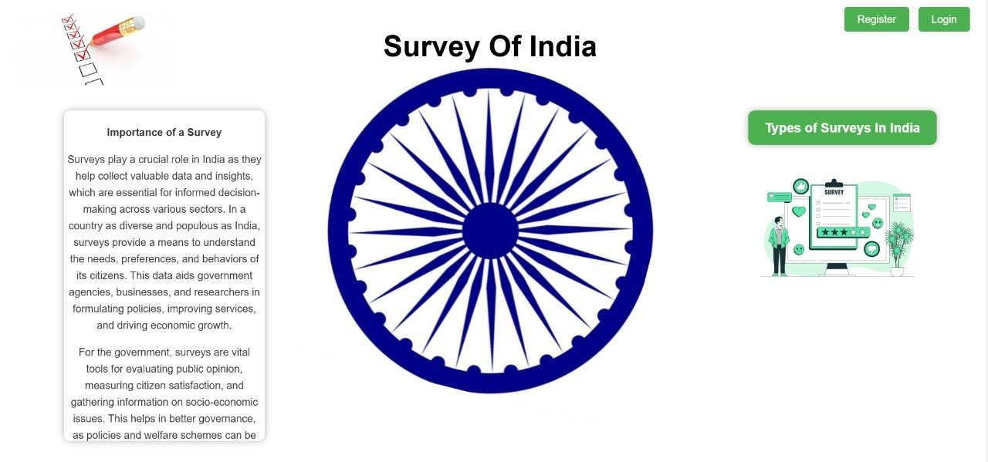

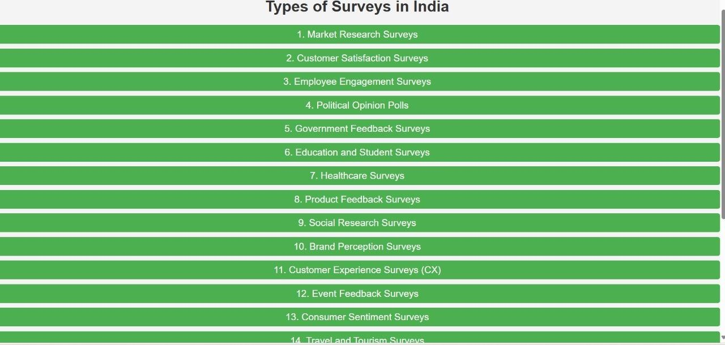

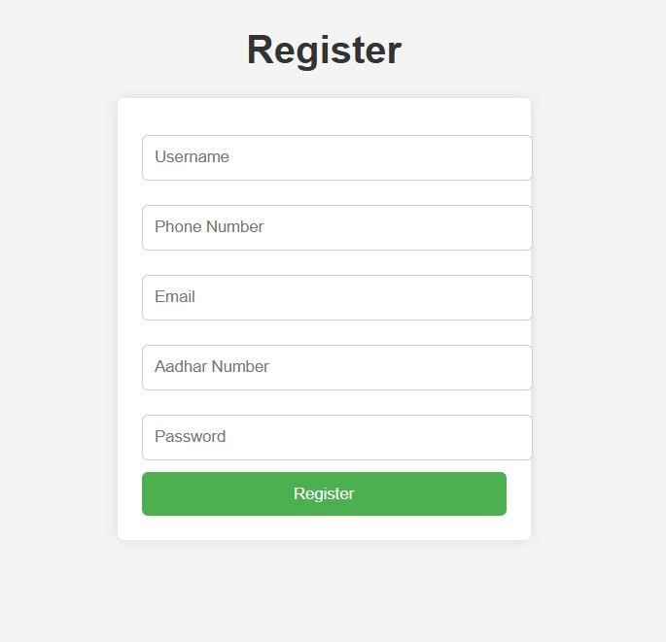

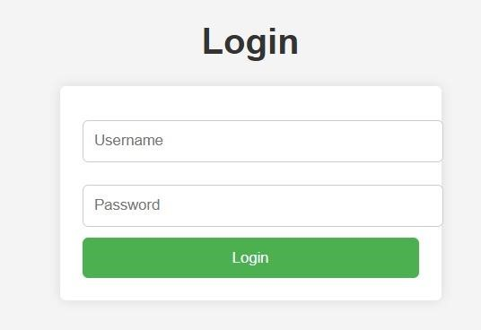

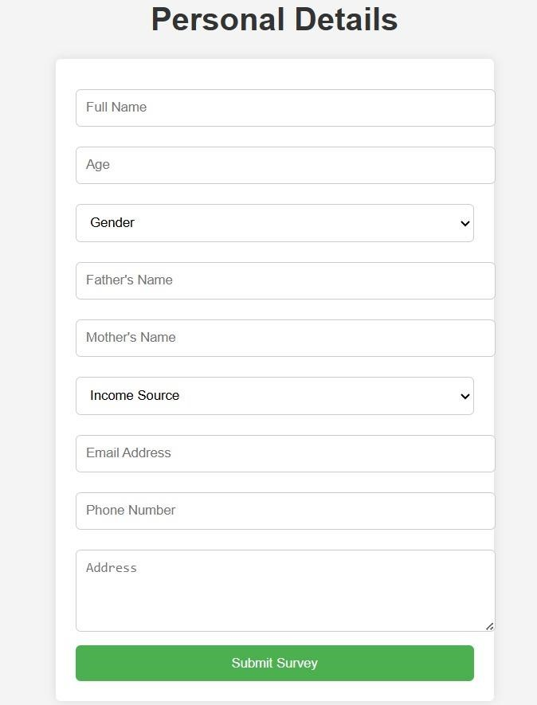

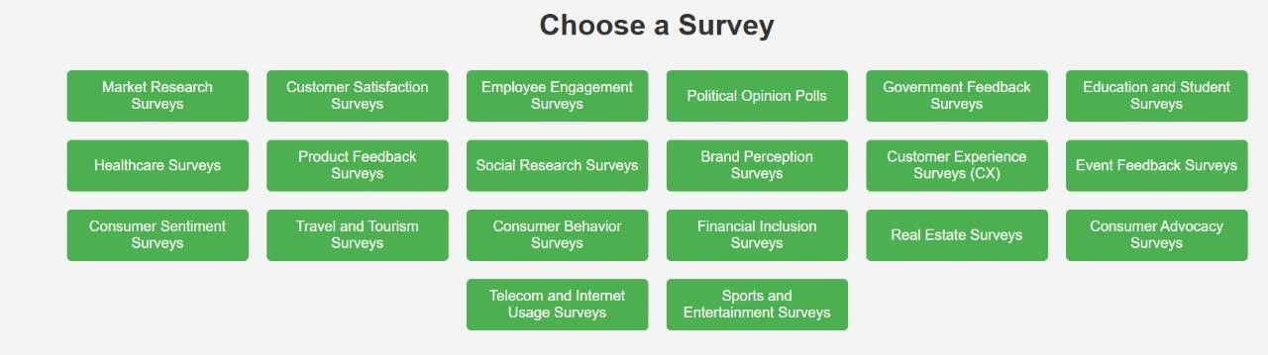

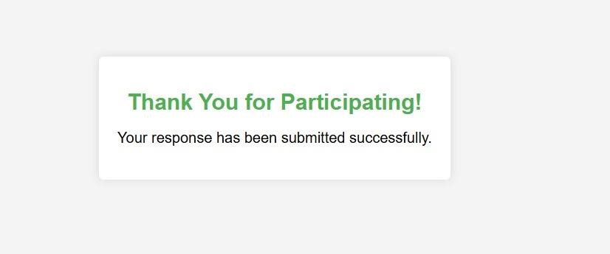**CONCLUSION:**

In conclusion, our website for conducting multiple surveys across diverse fields represents a significant step forward in efficient data collection and analysis. By enabling simultaneous surveys, it caters to a wide range of users, from researchers and businesses to individuals seeking feedback. The platform’s versatility and user-friendly interface ensure ease of access and navigation, fostering a seamless experience for both survey creators and respondents.

Additionally, its robust functionality and real-time data tracking empower users to make informed decisions based on reliable and actionable insights. This project has demonstrated the potential of technology in simplifying complex processes while maintaining scalability and adaptability. Moving forward, the website can be further enhanced with features like advanced analytics, AI-powered insights, and increased customization to meet the evolving needs of users. Overall, this project lays a strong foundation for innovative approaches to survey management and data-driven decision-making.

.

.